Lab: 9-10
Knapsack Algorithm
Lab Manual: Greedy Knapsack Algorithm
Lab Title: Implementation of the Greedy Knapsack Algorithm
Lab Number:
Objective:
- To understand and implement the Greedy Knapsack Algorithm.
- To solve optimization problems using a greedy approach.
- To analyze the time complexity and efficiency of the greedy method.

1. Introduction
The Greedy Knapsack algorithm is used to solve optimization problems where the goal is to maximize or minimize a specific objective, such as the total value of items carried in a knapsack with limited capacity. The algorithm selects items based on a specific criterion, ensuring a locally optimal choice at each step.

2. Greedy Approach
Problem Statement:
Given a set of items with specified weights and values, and a knapsack with a maximum weight capacity, select items to maximize the total value while ensuring the total weight does not exceed the capacity.
Steps:
- Compute the value-to-weight ratio for each item.
- Sort the items in descending order of their value-to-weight ratio.
- Add items to the knapsack in this order until the capacity is full or no more items can be added.
Algorithm Complexity:
- Sorting the items:
- Adding items to the knapsack:
- Total:

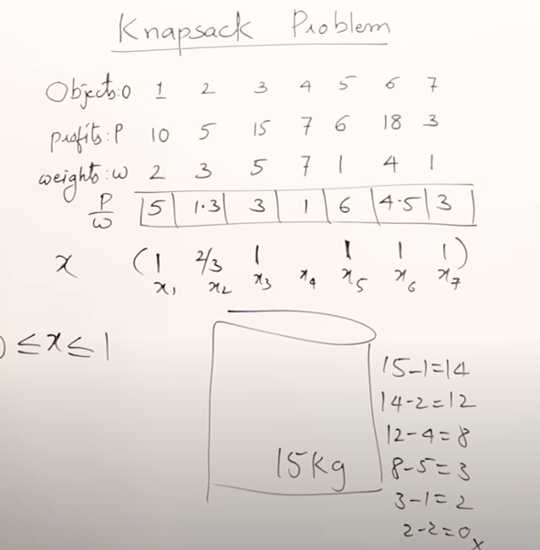

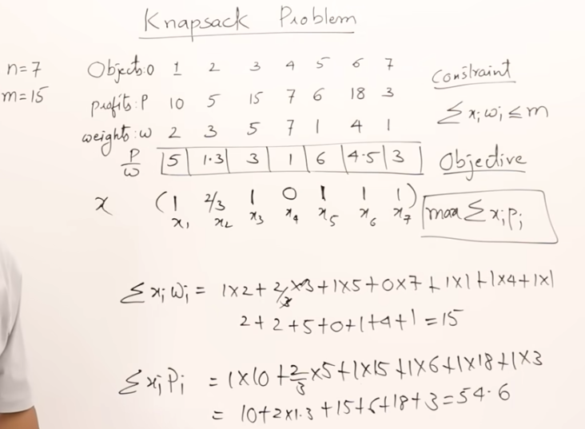

3. Implementation
Code:
# include<stdio.h>

void knapsack(int n, float weight[], float profit[], float capacity) {
float x[20], tp = 0; // tp=total profit, x=portion that will be taken
int i, j, u;
u = capacity;

for (i = 0; i < n; i++)
x[i] = 0.0;

for (i = 0; i < n; i++) {
if (weight[i] > u)
break;
else {
x[i] = 1.0;
tp = tp + profit[i];
u = u - weight[i];
}
}

if (i < n)
x[i] = u / weight[i];

tp = tp + (x[i] * profit[i]);

printf("\nThe result vector is:- ");
for (i = 0; i < n; i++)
printf("%f\t", x[i]);

printf("\nMaximum profit is:- %f", tp);

}

int main() {
float weight[20], profit[20], capacity;
int num, i, j;
float ratio[20], temp;

printf("\nEnter the no. of objects:- ");
scanf("%d", &num);

printf("\nEnter the wts and profits of each object:- ");
for (i = 0; i < num; i++) {
scanf("%f %f", &weight[i], &profit[i]);
}

printf("\nEnter the capacityacity of knapsack:- ");
scanf("%f", &capacity);

for (i = 0; i < num; i++) {
ratio[i] = profit[i] / weight[i];
}

for (i = 0; i < num; i++) {
for (j = i + 1; j < num; j++) {
if (ratio[i] < ratio[j]) {
temp = ratio[j];
ratio[j] = ratio[i];
ratio[i] = temp;

temp = weight[j];
weight[j] = weight[i];
weight[i] = temp;

temp = profit[j];
profit[j] = profit[i];
profit[i] = temp;
}
}
}

knapsack(num, weight, profit, capacity);
return(0);
}

Output:

4. Lab Exercises
- Implement the Greedy Knapsack algorithm for the following input:
  - Values: [50, 60, 140]
  - Weights: [10, 20, 30]
  - Capacity: 50
- Modify the code to print the total weight of the items included in the knapsack.
- Test the algorithm on datasets with duplicate values and weights to analyze behavior.
- Compare the greedy solution with a manually calculated optimal solution.

5. Questions
- How does the greedy approach ensure optimal solutions for the given problem?
- Why is sorting an important step in the greedy algorithm?
- Discuss the limitations of the Greedy Knapsack algorithm.
- Can the Greedy Knapsack algorithm be applied to solve all types of optimization problems? Why or why not?

6. Conclusion
The Greedy Knapsack algorithm provides an efficient method for solving optimization problems by making locally optimal choices. This lab demonstrates the practical application of greedy strategies and highlights the importance of selecting appropriate criteria for item selection.

